Teaching and Learning Policy

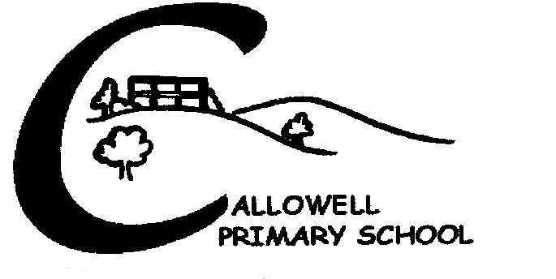

October 2021

Also refer to these documents:
- Curriculum Policy
- SEND Policy
- Assessment, Marking & Feedback Policy
- Behaviour, Discipline and Anti-Bullying Policy
- E Safety Policy

Confident, Caring and Creative.
Our school values underpin everything that we do.
At Callowell Primary School we believe in nurturing children that are Confident, Caring and Creative. We seek to do this by reflecting these values in teaching and learning, and every aspect of school life. The school aims to build the foundation for a lifelong love of learning, and to share an understanding that both adults and children learn new things every day. We maintain that learning is intrinsically rewarding and an enjoyable experience for everyone. Through our teaching, we equip children with skills, knowledge and understanding necessary to make informed choices. and to help children to grow to lead happy and fulfilling lives.
Our aim is that every child will feel confident to express their ideas and creativity within the safe and caring environment of our school community. We aim to provide a rich and varied learning experience that promotes confidence, caring and creativity, and encourages all children to recognise and develop their skills and abilities to their full potential.

Confident
We aim to support confident learners. Our staff have consistent, high expectations for all of our children. From our Pre-School to Year 6, we aim to build confidence and develop independence in all of our children, differentiating learning for individual needs. We encourage our children to be confident to take responsibility for their own learning, to be involved in reviewing the way they learn, and to reflect on how they learn.
We aim to support parents as partners in their children’s learning. Positive relationships between the school and parents are crucial in supporting children learn. In order for this to be a successful partnership we actively encourage parents to:
- read with their child on a regular basis
- attend parents evening to discuss their child’s progress and well being
- attend class assemblies and themed afternoons/mornings
- attend workshops led by teachers to find out how best to support their child’s learning at home

We aim to support confident teachers. Quality First teaching and learning at Callowell reflects the values of the school, and is promoted by supporting teachers to feel confident in what is expected from them.
Effective, high quality teaching and learning is characterised by:
- Teachers demonstrating confident knowledge of the subject that they are teaching
- The pace of all lessons is dynamic and engaging with maximised use of lesson time
- Tasks are carefully designed, chosen and adapted to meet the full range of learners’ needs and learning styles, allowing opportunities for open ended tasks.
- A range of effective teaching strategies is employed, so that all children are actively involved throughout the lesson.
- Children understand effective success criteria before tasks commence. Success criteria are modelled, referred to in the lesson and used for self-assessment. Children are encouraged to exceed expectations, and links are made to future learning.
- Children’s work which shows clear evidence of progression and challenge
- Learning is pitched appropriately with clear adaptation, including appropriate visual and kinaesthetic resources for different groups.
- All supporting adults effectively involved in promoting learning, providing challenge, and supporting children to be confident learners
- Children are given adequate lesson time to practise and embed new skills and knowledge. as well as time to practise their next steps
- Clear AfL between lessons as well as within lessons. Teachers use ongoing formative assessment to underpin the cycle of planning, teaching and learning, and to make judgements on children’s progress and attainment.
- Children are given clear, incisive feedback so that they know how to improve and are eager to do so. Children and parents know their next steps, and are regularly consulted with clear and timely information on how well their children are progressing in line with age related expectations
- Children are able to see that progress has been made in their learning and are given opportunities to respond to feedback and marking
- Carefully chosen closed questions are used strategically for AfL
- Carefully chosen open questions are used to extend children’s learning and understanding
- Activities and resources are organised to encourage children as independent learners
- Lesson resources are effectively prepared , available and distributed, minimising disruption and maximising learning time
- A very positive, purposeful atmosphere pervades all aspects of learning and behaviour within the class. Children feel safe and confident to express their ideas.
- Classroom displays are designed to support and celebrate learning, with learning wall resources used by children and referred to by teachers during the lesson to progress learning.

Caring
We aim to provide a caring and inclusive learning environment which celebrates all children’s learning achievements.
We believe that children learn best when:
- Children feel valued for their unique talents and strengths.
- Children’s voices are heard and are at the core of teaching and learning
- School and parents work together to support and celebrate children’s learning
- Children are immersed in their learning in creative and inspiring ways
- Children are surrounded by adults who positively encourage them and respond to their individual needs in sensitive and caring ways.
- Children are actively encouraged to understand and develop the characteristics of an effective and confident learner
The personal, social and emotional development of our children is at the heart of all that we do at Callowell. We aim to ensure that our staff feel valued and supported at school, and that they develop positive relationships with our children, in order to effectively cultivate the skills and attitudes children need to be confident, creative and caring members of the school community. Individual difference and diversity is celebrated at Callowell, and all children feel they are listened to, valued and cared for. Children are encouraged to share their ideas and these are used to inform future learning, so that children have an active role to play in their own learning journey. We aim to ensure that teaching embraces all styles of learning, and provides opportunities for children to express their unique ideas in different ways. The learning environment should promote children’s independence, with access to a range of resources, and individual work stations are created where this best meets an individual’s learning needs.

Creative
We aim to provide a broad and balanced curriculum, which promotes children’s creativity. Children benefit from as many first hand experiences as possible. Teachers listen to children’s ideas, respond to their voices, and use their expertise to blend these ideas with subject knowledge, skills and understanding into exciting and engaging subjects.
In order to provide high quality provision that nurtures creativity, we must:
- constantly adapt approaches to teaching in order to encourage flexible and creative use of skills
- provide a learning environment in which children can explore ideas, and feel supported to see making mistakes as a positive opportunity for learning
- immerse children in subjects by providing inspiring experiences and having key texts which teachers use to create a wide range of cross curricular learning opportunities.
- respond to the needs of children, reflect on the effectiveness of teaching and learning, and continuously adapt practice.
- seek opportunities to embed reading, writing, maths and communication in cross curricular subjects, adding to the progress of children across the curriculum
- use a range of strategies and learning styles, including: modelling, guided work, explanation, demonstration and scaffolding ideas.
- offer a range of ways to allow children to develop creative thinking and deepen their learning journey, by providing a variety of adult-led and child-led learning; partnered talk and peer exploration of ideas; mixed ability work; paired and individual work.

October 2021 Signed: ………………………………………………. Review October 22

