Callowell Primary School
School Uniform Policy

Contents
1. Aims
2. Our school’s legal duties under the Equality Act 2010
3. Limiting the cost of school uniform
4. Expectations for school uniform
5. Expectations for our school community
6. Monitoring arrangements
7. Links to other policies

1. Aims
This policy aims to:
- Set out our approach to requiring a uniform that is of reasonable cost and offers the best value for money for parents and carers
- Explain how we will avoid discrimination in line with our legal duties under the Equality Act 2010
- Clarify our expectations for school uniform

Statement of Intent
Callowell Primary is committed to promoting equality and value for money and to ensuring that no child is discriminated against due to their religion or belief, economic circumstances or social and cultural background.
This policy contains provisions to meet these objectives and has been created with health and safety, value for money and practicality at its heart. Additionally, it is important that our pupils feel a sense of belonging to our school.
We believe that wearing a smart and practical uniform allows all children, regardless of their backgrounds, to feel equal to their peers and confident in their appearance.
We also believe it is important for children to wear clothing that is conducive to a successful learning
environment, including activity-appropriate clothing, such as sports attire.

This policy has consulted the views of parents

2. Our school’s legal duties under the Equality Act 2010
The Equality Act 2010 prohibits discrimination against an individual based on the protected characteristics, which include sex, race, religion or belief, and gender reassignment.
To avoid discrimination, our school will:
- Avoid listing uniform items based on sex, to give all pupils the opportunity to wear the uniform they feel most comfortable in or that most reflects their self-identified gender
- Make sure that our uniform costs the same for all pupils

Allow all pupils to have long hair although it should be tied back for safety reasons.
Allow all pupils to style their hair in the way that is appropriate for school yet makes them feel most
Comfortable.
- Allow pupils to request changes to swimwear for religious reasons
- Allow pupils to wear headscarves and other religious or cultural symbols
- Allow for adaptations to our policy on the grounds of equality by asking pupils or their parents to get in touch with the school, where we will be able to answer questions about the policy and respond to any requests

3. Limiting the cost of school uniform
Our school has a duty to make sure that the uniform we require is affordable, in line with statutory guidance
from the Department for Education on the cost of school uniform.
We understand that items with distinctive characteristics (such as branded items, or items that have to have a school logo or a unique fabric/colour/design) cannot be purchased from a wide range of retailers and that requiring many such items limits parents’ ability to ‘shop around’ for a low price. The school logo is preferred but does not have to be part of a child’s school uniform.

We will make sure our uniform:
- Is available at a reasonable cost
- Provides the best value for money for parents/carers

We will do this by:
- Carefully considering whether any items with distinctive characteristics are necessary
- Avoiding specific requirements for items pupils could wear on non-school days, such as coats, bags and shoes
- Avoiding different uniform requirements for different year groups
- Avoiding different uniform requirements for extra-curricular activities
- Making sure that arrangements are in place for parents to acquire second-hand uniform items
- Avoiding frequent changes to uniform specifications and minimising the financial impact on parents of any changes
- Consulting with parents and pupils on any proposed significant changes to the uniform policy and carefully
- Consulting with parents and pupils on any proposed significant changes to the uniform policy and carefully
- Considering any complaints about the policy

4. Expectations for school uniform
4.1 Our school’s uniform (Please refer to Appendix 1)
The school endeavours to ensure that our uniform is as gender neutral as possible.
The uniform is as follows:
∙ Navy sweatshirt or navy cardigan
∙ Gold/Yellow polo shirt
∙ Navy or black trousers, or leggings
∙ Navy or black skirt (in summer, a blue and white summer dress may be worn)
∙ Grey, Black, sensible shoes as well as black trainer shoes. (Trainer shoes with coloured logos or soles are not
permitted).
∙ Grey, black or white socks
∙ Grey, navy or black tights
High heels are not permitted: sensible, plain black shoes must be worn by both boys and girls. Black jeans
and leggings are not permitted in day-to-day uniform. All items of clothing and footwear must be labelled with the pupil’s name.

Our PE Kit
Children are asked to wear their PE kit in on PE days. This is with the exception of Owls class as they are encouraged to change in school as part of their EYFS development.
The PE kit is as follows:
∙ Plain yellow T-shirt (with or without the school logo)
∙ Navy tracksuit bottoms or leggings (Winter months)
∙ Navy shorts
∙ Trainers or black pumps.
All items of clothing and footwear must be labelled with the pupil’s name.

Forest School Clothing
Children are asked to bring into school on the day of their Forest School session their Forest School
clothing.
Parents/ carers will be informed of their children’s Forest School days via newsletter, our website and/or via
DoJo.
Parents/carers are responsible for ensuring that their child is dressed appropriately for Forest School.
Forest School clothing is as follows:
∙ Waterproof coat (or waterproof jacket in warmer weather)
∙ Comfortable tracksuit bottoms or leggings (not shorts)
∙ Long-sleeved top
∙ Wellington boots or old trainers
∙ Appropriate hat for the weather
∙ Scarf and gloves (in colder weather)
All items of clothing and footwear must be labelled with the pupil’s name.

Jewellery
The only permitted jewellery that may be worn is:
∙ Stud earrings (no other piercings are permitted)
∙ A sensible wristwatch
Jewellery is the responsibility of the pupil and not the school. Lost or damaged items will not be refunded. All
jewellery must be removed during practical lessons, for example, PE lessons / swimming lessons. If children
cannot remove their own earrings, then this should be done at home on the day of PE.

School Bag
Pupils must use an appropriately sized waterproof bag to carry their books and sandwich boxes. It should hold children’s books and reading diaries comfortably without causing any damage. Large bags / large rucksacks are discouraged for day-to-day lessons due to space on children’s pegs. School bags featuring deemed inappropriate images, slogans or phrases are not permitted. The school encourages pupils to bring non-valuable bags to school. The school will not be liable for lost or damaged school bags.

Water Bottle
All children should bring a water bottle into school every day: this can be refilled by children whenever
necessary during the day. Water bottles must be labelled with the pupil’s name.

Hairstyles
Hairstyles should be smart and moderate in style. Brightly coloured hair is not permitted.
Pupils with what could be deemed extreme hairstyles may be exempt from the rule above on racial or religious
grounds. The Head Teacher will take each individual pupil’s scenario into consideration.
Long hair should be tied up. This is to avoid health and safety risks and ensure that children’s vision is not
impeded. Large, excessive hair accessories should not be worn; however, small hair clips or plain headbands are acceptable. Hair extensions are not permitted.

At the Head Teacher’s discretion, there may be exceptions to the above in extreme circumstances e.g. a pupil may be permitted to cover their hair if they have hair loss / illness etc.

Make-Up
Nail varnish, False nails and nail extensions are not permitted.
Children are not allowed to wear make-up. Pupils wearing make-up are required to remove it or, if appropriate, will be sent home to remove it.

At the Head Teacher’s discretion, there may be exceptions to the above in extreme circumstances e.g. a pupil may be permitted to cover heavy scarring/skin damage.

Adverse Weather
Hot Weather Everyone working at/attending the school during hot weather conditions is required to wear
sun-safe clothing that covers as much of their skin as possible.
This includes wearing:
∙ Loose fitting tops with collars or covered necklines
∙ Tops that cover the shoulder area
∙ Grey, navy or black shorts or pale blue/navy and white checked or striped summer dresses of an appropriate length (if families wish to)
∙ Sun-safe hats
∙ Sunscreen should be applied in the mornings before coming to school. No sunscreen creams should be
brought into school.
During hot weather, lightweight clothing is required to reduce the risk of overheating. Pupils are not required to wear their jumpers/cardigans during heatwaves.

Cold Weather
During cold weather, pupils should be provided with additional cold weather clothing such as scarves, gloves, coats and hats when they are outside.
Additional layers underneath the usual school uniform are accepted. Where possible, pupils not wearing warm clothing are provided with spare clothing if going outside during break and lunch times.

Labelling
All pupils’ clothing and footwear must be clearly labelled with their name. Clothing and footwear are the
responsibility of the pupil and not the school. If a child goes home in another child’s clothing by accident, for example, their jumper, parents/carers should send the clothing not belonging to them back into school to their child’s class teacher.

4.2 Where to purchase it from
Details of the school uniform are available from our school office. All uniform items can be purchased from Batemans in Stroud High street, other high street shops, supermarkets or online at myclothing.com.
Second-Hand Uniform will be available from school.

5. Expectations for our school community
5.1 Pupils
Pupils are expected to wear the correct uniform at all times (other than specified non-school uniform days)
while:
- On the school premises
- Travelling to and from school
- At out-of-school events or on trips that are organised by the school, or where they are representing the school (if required)
Pupils are also expected to contact their class teacher and senior leadership team if they want to request an amendment to the uniform policy in relation to their protected characteristics.
5.2 Parents and carers
Parents and carers are expected to make sure their child has the correct uniform and PE kit, and that every
item is:
- Clean
- Clearly labelled with the child’s name
- In good condition

Parents are also expected to contact the school if they want to request an amendment to the uniform policy
in relation to:
- Their child’s protected characteristics
- The cost of the uniform
Parents are expected to lodge any complaints or objections relating to the school uniform in a timely and
reasonable manner.

Disputes about the cost of the school uniform will be:
- Resolved locally
- Dealt with in accordance with our school’s complaints policy
The school will work closely with parents to arrive at a mutually acceptable outcome.

5.3 Staff
Staff will closely monitor pupils to make sure they are in correct uniform. They will give any pupils and families
breaching the uniform policy the opportunity to comply, but will follow up with the headteacher if the situation doesn’t improve.
Ongoing breaches of our uniform policy will be dealt with using our school’s behaviour policy.
In cases where it is suspected that financial hardship has resulted in a pupil not complying with this uniform
policy, staff will take a mindful and considerate approach to resolving the situation.

5.4 Governors
The governing board will review this policy and make sure that it:
- Is appropriate for our school’s context
- Is implemented fairly across the school
- Takes into account the views of parents and pupils
- Offers a uniform that is appropriate, practical and safe for all pupils

The board will also make sure that the school’s uniform supplier arrangements give the highest priority to
cost and value for money, for example by avoiding single supplier contracts and by re-tendering contracts
at least every 5 years.

6. Links to other policies
This policy is linked to our:
● Behaviour policy
● Equality information and objectives statement
● Anti-bullying policy
● Complaints policy

Date reviewed by Governing Body: ……………………………………

Signed: …………………………….

Next review date: March 2025

Appendix 1 – Quick Reference Guide to School Uniform.

Navy Fleece | Navy Jumper/Sweatshirt | Navy Cardigan | Gold/Yellow Polo-shirt
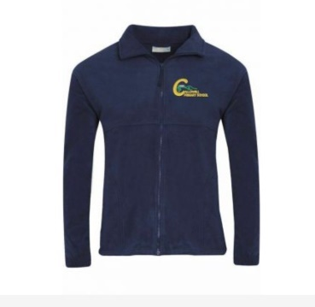 | 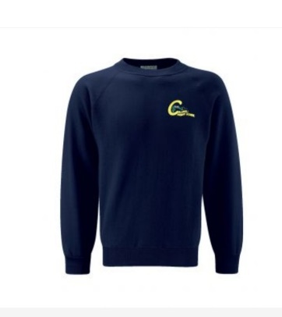 | 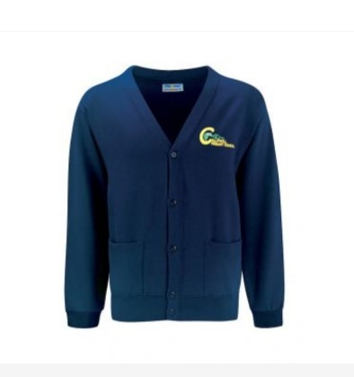 | 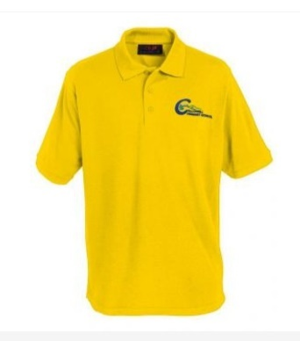
Navy or Black Trousers | Navy or Black Skirt/Pinafore | Navy or Black Shoes | Blue Check Summer dress
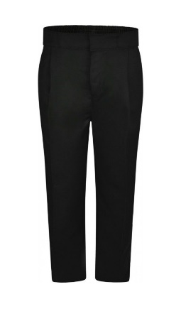 | 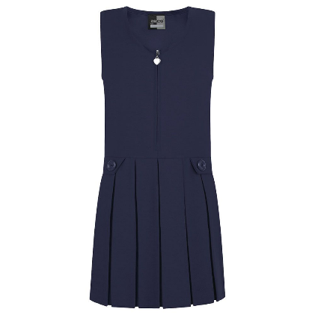 | 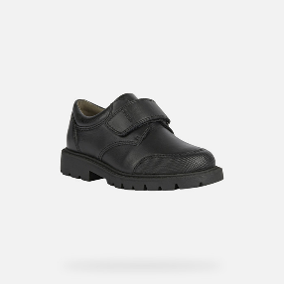  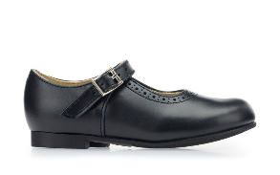 | 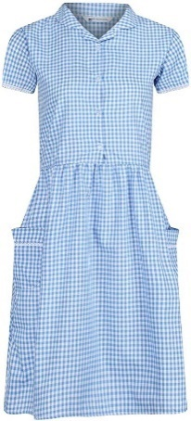
PE Kit
Navy Shorts | Gold/Yellow PE T-shirt | Navy Tracksuit bottoms | Plain black/Navy trainers or daps
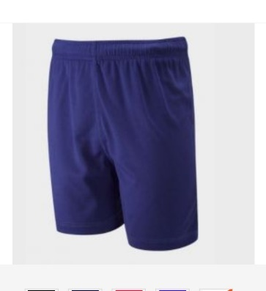 | 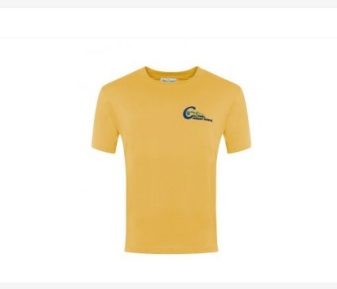 | 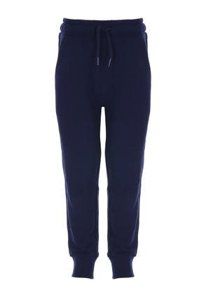 | 