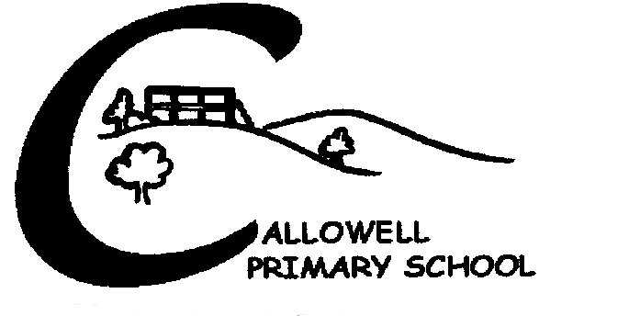
Jumping Beans Food Policy

We are committed to ensuring that the children at Jumping Beans grow into healthy adults, we regard snack and mealtimes as an important part of our day using the opportunity to learn about healthy eating.

Aims
- We aim to give children the opportunity to have a fresh, healthy and balanced meals.
- To help children learn what healthy food is.
- To give children the skills they need to make the right choices regarding food and drink.
- We have a rolling snack in the morning which meet children’s individual dietary needs also giving the opportunity to socialise together, learn about healthy eating, developing cutting, pouring skills and the confidence to explore new tastes and textures and promote their knowledge of healthy eating.

Procedures

Before a child attends the setting the parents are asked to complete a registration form that includes details of any specific dietary requirements, allergies, also any significant likes or dislikes.

- We display current information about individual children’s dietary needs so all staff are fully informed.

- We provide meals and snacks that are healthy and well balanced.

- We ensure all staff receive food hygiene training.

- We include foods from different cultural and backgrounds.

- We organise snack and mealtimes, so they are social occasions in which the staff and children take part, also developing independence through making choices and preparing, serving food and drink themselves.

- To protect children with food allergies we discourage children from sharing or swapping foods with each other.

- We provide semi-skimmed milk at snack time.

- Children are supervised at all times by a member of staff during all mealtimes.

School lunches
We will serve only healthy food and drink for our school lunches. The lunches will be prepared by the local authority’s approved catering contractor who will make a commitment to provide healthy food. A basic requirement will be that they provide a vegetarian option each day, that they always serve vegetables and fruit, and that all lunches have a balanced nutritional value.
Packed Lunches
The parents of children who bring packed lunches will be made aware of our healthy-school policy and our encouraged to provide their children with a healthy lunchbox. We discourage sweet or fizzy drinks.
Due to some of our children having severe allergies to nuts we ask that children do not bring in any nut-based products or have nut butter in their sandwiches.

Signed: …………………………… Date …………

Reviewed

