

**Callowell Primary School**

**SEN Information Report**

**2024/25**

All schools need to provide a Special Educational Need and Disabilities ( SEND) Information Report and school offer, The school Offer is a part of the wider Local Authority Offer, and is based on the requirement for all schools to outline the support available to children with SEND. We have decided to combine these two documents into one, and include information on our SEND policy also, so you have one place to find out all the information you need.

Callowell Primary School Values the contribution that every child can make and is supported by the Local Authority to ensure that all pupils, regardless of their specific needs, make the best possible progress. The school seeks to raise the achievement, remove barriers to learning and increase physical and curricular access to all. All children and young people with Special Educational Needs or Disabilities ( SEND) are valued, respected and considered equal members of the school. As such, provision for pupils with SEND is a matter for the school as whole. All teachers are teachers of pupils with SEND. The Governing Body, Head teacher, SENDco and all other members of staff are responsible for ensuring good teaching of children with SEND. This local offer is in line with the school SEND policy which can be accessed via the website, [www.callowellschool.co.uk](http://www.callowellschool.co.uk/) by contacting the school office.

*In brief: The aim of this information.* report *is to* explain *how* we implement our SEND policy so *that* you know *how* SEN support works in our school.

To make it as easy as possible to find the information you require, we have laid it out as a series of questions parents/ carers often ask about a school and what happens for children with SEND. If there is any question you would like answered that isn’t included below or you would like additional information, please let us know.

1. **What is SEND?**

SEND ( Special Educational Needs and /or Disability) is defined in the code of practice as having a learning difficulty or disability that calls for special educational provision to be made for them. Children having learning difficulties if they:

* + - Have a significantly greater difficulty in learning than the majority of others of the same age.
    - Have a disability that prevents or hinders him or her from making use of educational facilities of a kind generally provided for others of the same age in mainstream school.
    - Are under compulsory school age and fall within the definitions above or would so do if special educational provision was not made for them.

1. ***What* types *of* SEN does the school provide for?**

Our school strives to provide provision for all children with SEND. Under the Code of practice (2015). SEND is organized into the following four areas of need:-

|  |  |
| --- | --- |
| **AREA OF NEED** | **CONDITION** |
| Communication and  interaction | Autism spectrum disorder |
| *Speech* and language difficulties |
| *Cognition.* and learning | Specific learning difficulties, including dyspraxia, dyscalculia |
| Moderate learning difficulties |
| *Severe* learning difficulties |
| Social, emotional and mental health | Attention. deficit *hyperactive* disorder  (ADHD) |
| Attention. deficit disorder (ADD) |
| Sensory and/or physical | Hearing impairments |
| Visual impairment |
| Multi-se.sory impairment |
| Physical impairment |

1. **Who is the SENDCO?**

Our SENCO *is* Ms Charlotte Black

*She* can be contacted by email:-cblack@cbat.academy

*She can also be contacted by phoning the school office on a Monday to Wednesday.*

* + She has over 10 years' experience as SENDco.
  + The SENDco is a qualified teacher with a BA ( QTS) from Warwick University)
  + She achieved the National Award in Special Education Needs Co- coordination in 2014 from Gloucestershire University.2
  + She is also a THRIVE practitioner helping to support children with social and emotional needs
  + The SENDco is Elklan trained with some knowledge of Speech and language difficulties
  + She has obtained a level 3 certificate in understanding Autism
  + Along with achieving a diploma in psychology from the Open

University.

**3b) What is the role of the SENCO in a mainstream primary school *?***

At Callowell Primary School, in line with the special educational Needs and Disability Code of Practice ( 2015) and mandatory standards identified within the National SENDCO Award training, The SENDco has an important role to play with the headteacher and governing body in determining the strategic development of SEND policy and provision. They are most effective in that role if they are part of the senior leadership team ( Section 6:87). The SEND Co-ordinator ( SENDco) responsibilities may include:-

* + Overseeing day to day operation of the schools SEND policy
  + Co-ordinating provision for children with special educational needs
  + Liaising with a advising fellow teachers
  + Managing learning support and teaching assistants
  + Overseeing the records of all children with SEND
  + Liaising with parents of children with SEND
  + Contributing to the in-service training of staff
  + Liaising with external agencies including the SEND team, Educational

Psychology services, Health and Social services and voluntary bodies

* + Updating the SEN registers and making sure there are records of your child’s progress and learning needs.
  + Working with class teachers, parents, children and other professionals to write EHC plans.

**3c) What is the role of the class teacher and what are they responsible for in regards to SEND children in a mainstream primary school*?***

The class teacher is usually your first point of call, they work with the child on a daily basis and complete, assessments and planning related to your child. All *of* our teachers receive *in-house* SEN *training, and* are supported by *the* SENCO to meet *the needs of children who have* SEN.

As stated in the 2015 SEN code of practice they are responsible for;-

* + Keeping appropriate records on your child and their progress, which can be used to identify areas of support.
  + Working with the SENDco to identify, plan and deliver any additional

help your child may need.

* + Working with the SENDco to share and review assessment and progress information.
  + Informing you as parents of progress at Parents Evenings
  + Ensuring that all additional adults working with your child in school are helped to deliver the planned work for your child, so that they can achieve the best possible progress.
  + Working with outside agencies who may offer advice and help to support your child
  + Ensuring they follow the school’s SEND policy.

**3d) What is the role of the Teaching Partner’s at Callowell Primary School and what are they responsible for in regards to SEND children in a mainstream primary school?**

We have a wonderful team of Teaching Partners who are trained to support in class and deliver a variety of interventions and help the teacher to adapt the lessons so SEND children can access and progress.

**3e) What is the role of the Headteacher and what are they responsible for in regards to SEND children in a mainstream primary school*?***

The headteacher is responsible for:

* + The day to day management of all aspects of the school, including the support for children with SEND.
  + Ensuring that the needs of SEND are met.
  + Keeping the governing Body up to date about any issues in the school relating to SEND
  + Working with the School Administer and Governors to plan and spend money for children with SEND effectively, monitoring the impact of such spending.

**3f) What is the role of the SEN Governor and what are they responsible for in regards to SEND children in a mainstream primary school*?***

Our SEND Governor is ________________. They are kept informed of SEND in the school by the SENDco, Head teacher and the SENDco’s annual report, They will make sure that the necessary support is made for any child who attends school and has SEND.

1. **What training have staff received in 2024?**

* Supporting *children with* SEN *in* EYFS *and* KS1
* The Thrive approach, an introduction to the Thrive approach.
* Level 1 Dyslexia and what adaptations are needed to support children with Cognition and learning needs.

1. **What external agencies and experts do we access?**

Sometimes we *need* extra help to *offer* our *children the* support *that* they *need. Whenever* necessary we will work *with* external support services to meet *the needs of* our *children with* SEN *and* to support *their families. These include:*

* + Speech *and* language therapists
  + Specialist Teachers (Advisory *Teaching* Service)
  + Educational psychologists
  + Occupational therapists
  + GPs or paediatricians
  + School nurses
  + Child *and* adolescent mental health services (CAMHS)
  + Social services *and other* LA-provided support services
  + Voluntary sector *organisations*

1. **What should I do if I think my child has SEND or if I am concerned about my child’s progress in school?**

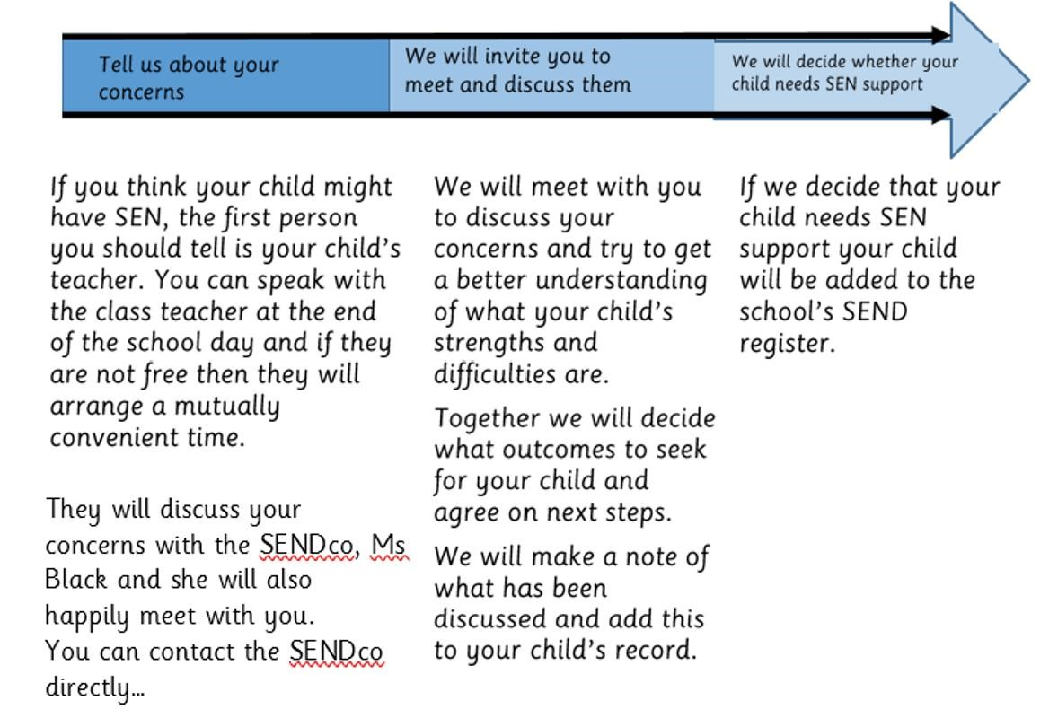 cblack@cbat.academy

**7) How will the school know if my child needs SEN support?**

All class teachers are aware of SEND and are on the lookout for any children who are not making the expected progress in their school work or socially. If the teacher notices that a child is finding things difficult they try to find out if the child has any gaps in their learning. If they find a gap, they will give the child extra tuition or adaptations to their lesson to try to fill it.

If the child is still struggling to make the expected progress, the teacher will talk to the SENDco, and will contact you to discuss the possibility that your child has SEN.

The SENDCo will have a discussion with your child’s teacher, to see if there have been any issues with, or changes in, their progress, attainment or behavior. They will also compare your child’s progress.

**7b) How will the school let me know if they have a concern about my child’s learning and progress in school?**

Regular meetings with staff are held to discuss the progress of all children to identify if any children are regularly causing concern. Areas of concern are monitored by the class teacher, senior leadership team and SENDco. If your child is not making progress the school will set up a meeting to discuss this in more detail. It may also be discussed with you at a parents evening.

During this meeting we will ask your opinion and speak about your child to get their input as well. We will listen to any concerns you have. Based on all the available information, we will plan and explain any additional support your child may receive and decide whether your child needs SEN support. If your child does need support they will be placed on the ‘ Graduated pathway’. Their name may be added to the School’s SEN or monitoring register, and school will work with you to create a SEN Myplan for your child.

**8) How will the school measure my child’s progress?**

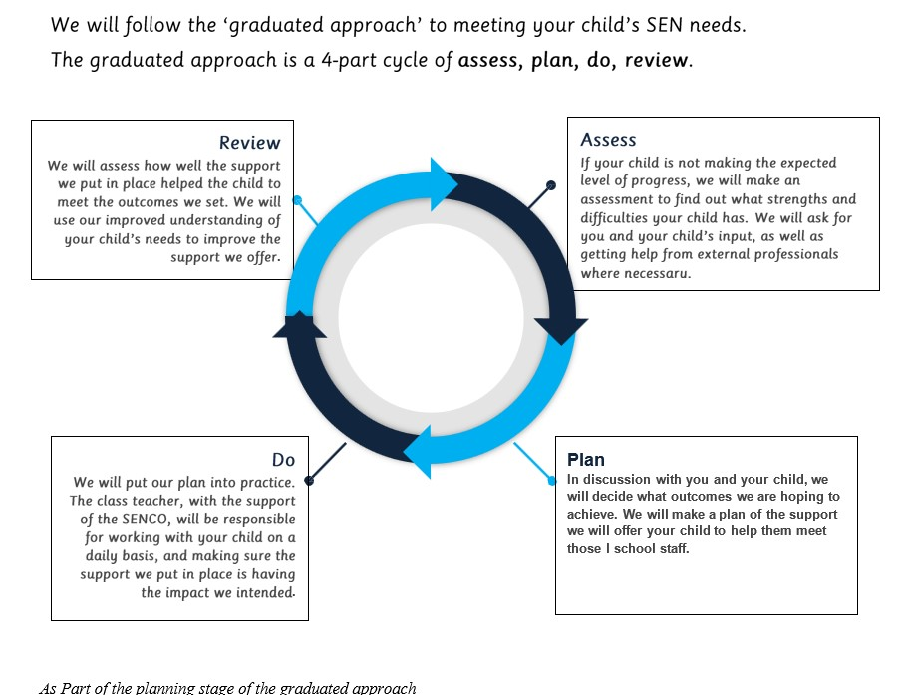

As part of the planning stage of the graduated approach, we will set outcomes that we want to see your child achieve.

Whenever we run an intervention with your child, we will assess them before the intervention begins. This is known as a ‘baseline assessment’. We do this so we can see how much impact the intervention has on your child’s progress.

We will track your child’s progress towards the outcomes we set over time and improve our offer as we learn what your child responds to best.

This process will be continual. If the review shows a child has made progress, they may no longer need the additional provision made through SEN support, for others, the cycle will continue and the school’s targets, strategies and provisions will be re visited and refined.

9**) How will I be involved in decisions made about my child’s education?**

We will provide reports on your child’s progress

Your child’s teacher will meet you to review your child’s Myplan/ Myplan + to

* Set clear outcomes for your child’s progress
* Review progress towards *those* outcomes
* Discuss *the* support we will put in place to help your child make *that progress*
* Identify *what* we will do, *what* we will ask you to do, and *what* we will ask your child to do

*The* SENCO may also attend *these* meetings to provide extra support.

We know *that* you are *the* expert when *it* comes to your child's needs and aspiration. We want to make sure you *have a* full understanding *of how* we are trying to meet your child's needs, so *that* you can provide insight into *what* you think would work best *for* your child.

We also want to *hear from* you *as* much *as* possible so *that* we can build *a* better picture *of how the* SEN support we are providing impacts your child outside *of* school.

*If* your child's needs or aspirations change *at* any time, please let us know *right* away so we can keep our provision *as* relevant *as* possible.

*After* any My Plan discussion we will make *a* new plan. *This* record will be shared *with* all relevant *staff,* and you will be given *a* copy.

*If* you *have* concerns *that* arise between *these* meetings, please contact your child's class teacher

1. **How will my child be involved in decisions made about their education?**

*The* level *of* involvement will depend on your child's age and needs. As children are not all *the* same we will decide on *a* case-by-case *basis, with* your input.

We may seek your child's views by asking *them* to:

* + Attend meetings to discuss *their* progress and outcomes
  + Prepare *a* presentation, written statement, video, drawing, etc.
  + Discuss *their* views *with a* member *of staff who* can *act as a* representative during *the* meeting

1. **How will the school adapt its teaching *for* my child?**

Your child's teacher *is* responsible and accountable *for the* progress and development *of* all *the* children in *their* class.

High-quality teaching *is* our *first* step in responding to your child's needs. We will make sure *that* your child *has* access to *a* broad and balanced curriculum.

We will adapt *how* we *teach* to suit *the* way *the* child works best.

*These* adaptations include:

* 1. Making sure all children are able *to* access *the* curriculum, *for* example, by grouping, 1-to-1 work, *adapting the teaching* style or *content of the* lesson, etc.
  2. *Differentiating* our *teaching, for* example, *giving* longer *processing times, pre-teaching of* key vocabulary
  3. *Adapting* our resources *and staffing*
  4. *Using* recommended *aids,* such *as* visual timetables, larger *font,* etc.
  5. *Teaching assistants* supporting *children on a* 1-to-1 *basis*
  6. *Teaching assistants* supporting *children in* small groups

|  |  |  |
| --- | --- | --- |
| *Wave* 1  *Interventions* (Quality *Teaching and adaptations)* | *Wave* 2  *Interventions*  (Additional  *Interventions* - *time* limited) | *Wave* 3  *Interventions* (Highly  Personalised  *Interventions)* |
| *Differentiated* curriculum *planning* | Little Wandle Keep Up | Outside *Agencies*  Speech *and* |
| Appropriate resources - word *banks,* pencil grips, visual *aids* etc.  Visual timetables | Small Group work  (Maths, */writing)*  Early Literacy Support | Language Therapy  Fizzy  1:1 support *from* |
| Structured class *routines* | Extra reading sessions | *individual* TA  Social stories |
| *In* class support *from* Class TA  Social *Development*  – NITTi programme | Language *for Thinking*  Hands *on* Motor Skill programme  Widget *Online* | Risk    *assessment*  *Intimate* Care Plan  Physical access resources  (wheel *chair ..*  *.)* |

* 1. *We may also provided interventions.*

These *interventions* are part *of* our *contribution to* Gloucestershire's local *offer.*

[https://www.glosJamiliesdirectory.org.uk/kbS/ gloucs/glosJamilies/home.page](https://www.glosfamiliesdirectory.org.uk/kb5/gloucs/glosfamilies/home.page)

We *remain open to new* materials *and* approaches *and if* they *offer* more *than* our current *interventions* we will seek *to* sensitively adjust our practice *to* better meet *the needs of* our SEN *children.*

1. **How will the school evaluate whether the support *in* place *is* helping my child?**

We will evaluate *the effectiveness of* provision *for* your child *by:*

* 1. Reviewing *their* progress towards *their* goals *each* term
  2. Reviewing *the* impact *of interventions once* completed
  3. *Monitoring* by *the* SENCO
  4. Holding *an* annual review.

1. **How is extra support allocated?**

The school budget, received from Gloucestershire Local Authority, includes money for supporting children with SEND. Money is also received from other local authorities if a child is supported by them.

* The headteacher decides on the budget for SEND in consultation with the school governors.
* Funding is used for employing Teaching Assistants to work with children with EHC Plans and targets individuals and groups. Staff have access to regular in-house CPD or external training when required.
* Other resources are purchased for use with individuals or groups where appropriate.
* All resources/training and support are reviewed regularly and changes made as needed.

**13b) How will the school resources be secured *for* my child?**

It may be *that* your child's *needs mean* we *need* to *secure:*

* + Extra *equipment* or *facilities*
  + More *teaching assistant* hours o Further *training for* our *staff* o External specialist expertise

*If this is the* case, we will consult *with* external *agencies* to seek *recommendations on what* will best help your child access *their* learning *and how* to access these. Extra funding may need to be applied for through a Local Authority Annual Review for EHCP’s, TALC funding or other charities to enable the above.

1. **How will *the* school make sure my child *is included in* activities alongside children who *don't* have SEND?**

All *of* our extra-curricular activities *and* school visits are available to all our children.

All *children* are encouraged to go *on* our school trips *and* to take part *in* sports days, school plays *and* wow days.

We will make whatever reasonable adjustments are *needed* to help ensure *that* all *children can* be included *in* all activities.

1. **How does the school make sure the *admissions* process *is fair for* children with SEN or *a* disability?**

*The* Local Authority decides our *admissions, therefore parents* should *contact the* Local Authority to *find* out about our *admissions arrangements* [http://www.gloucestershire.gov. uk/schooladmissions](http://www.gloucestershire.gov.uk/schooladmissions)

*The* school acknowledges *in* full *its* responsibility to *admit children with* already *identified* special educational *needs, as* well *as identifying and* providing *for those not* previously *identified as having* SEND.

*If* your child *has an* Education Health Care Plan (EHCP) *in* place *before* they are due to start school, there *is a different admission* procedure *for* applying *for a* Reception place. At *the* Annual Review (prior to your child *starting* school) there should be *an* opportunity to discuss *which* school may be suitable to meet your child's *needs.* A copy *of the* Annual Review will be *sent* to *the* County Council's school *named in the* report to request *a* place *for* your child.

Applications do *not need* to be submitted *for children with an* EHCP *as* places are automatically allocated *in the* school *that has been named in the* child's EHCP.

1. **How does *the* school support children with *disabilities?***

*The* school *is* committed to *providing an environment* accessible to all. *When* necessary we seek help *from* specialists to *ensure* all *children with a* disability have *the* same *opportunities in* school *as their* peers. *This* may involve *accessing* auxiliary *aids and* specialist advice.

.

1. **How will the school be accessible to children with SEND?** *( Please refer to the SEND policy/ accessibility policy)*

* + *Classroom equipment is accessible to all children regardless of their needs, and where additional needs are identified ( visual impairment) further advice is sought.*
  + *Extra curricular activities are available and accessible to children with SEND.*
  + *Children with specific needs will have members of staff to help them access the school environment, curriculum and clubs.*
  + *Our classrooms are communication friendly and our teachers use whole class visual timetables to schedule the day.*
  + *The whole school entrance is accessible to all children with SEND providing appropriate facilities*

1. **How will the school support my child's mental health *and* emotional *and***

**social development?**

We provide support *for children* to progress *in their* emotional *and* social development *in the* following ways:

* 1. *The* school uses *The* Colour Monster to help *with understanding and naming emotions in Early Years. Children* are *encouraged* to try *activities* to help *with their* wellbeing *in* class-: *mindfulness* colouring, yoga etc
  2. *In the rest of the school staff use the Name it to Tame it approach ( NITTI) which is adapted from the five point scales.*
  3. We follow the Jigsaw programme to support mental wellbeing
  4. We have *the THRIVE Room* where *children can* be supported to help regulate *and understand their emotions*
  5. We have *a qualified* Emotional Literacy Support *Assistant and a*

*THRIVE Practitioner*

* 1. **A** zero tolerance approach to bullying

1. **What support will be available *for* my child *as* they *transition between* classes or *settings* or *in preparing for* adulthood?**

***Between* years**

To help *children with* SEN *children* be prepared *for a new* school year we:

* + 1. Ask *both the* current teacher *and the next* year's teacher to meet to discuss *the* child's SEN *and* My

Plan

* + 1. Provide *opportunities for children* to *visit their new* teacher *and their new* classroom *in informal* ways
    2. Have *moving* up *sessions*
    3. Provide *information* booklets *for* children

# Between schools

When your child *is* moving on *from* our school, we will ask *you* and your child *what* information *you* want us *to* share *with the* new setting.

The SENCO *of* the local secondary schools have *a* meeting *with* our SENCO.

*They* will discuss *the* needs *of* all *the* children *who* are receiving SEN support. Children will be prepared *for the* transition *by:*

1. Having *visits to the* Secondary School
2. Having individual information booklets supplied *(for children who* need *them)*
3. Individual *visits to the* Secondary School, *if* needed
4. Being part *of the buddy system* in place *for* all children
5. Members of staff attend the Advisory Teaching Service Transition Conference where appropriate

1. ***What* support *is* in place *for* looked-after and previously looked-after *children with* SEN?**

Mr Roberts will work *with* Ms Black, our SENCO, to make sure *that* all teachers understand *how a* looked-after or previously lookedafter child's circumstances and their SEN *might* interact, and *what the* implications are *for* teaching and learning.

Children *who* are looked-after, or previously looked-after, will be supported much in *the* same *way* as any other child *who has* SEN. However, looked-after children will also have *a* personal education plan (PEP). We will make sure *that the* PEP and any SEN support plans or EHC plans are consistent and complement one another.

1. ***What* should** I do *if* I **have *a* complaint about *my* child's SEN support?**

We hope *that* all SEN children are *happy* and will have their needs met in school. However, *if you* have concerns about SEND provision and *you wish* to make *a* complaint we would like to have *the* opportunity to discuss *this* and to *try* to resolve *the* problem. *If you* are concerned about anything *the* class teacher, Mr Roberts , or _________________ *(who is the* governor *for* SEND) who will all be *happy* to talk *with you* to *try* to help resolve any problems.

*If the* issue *is* not able to be resolved *you may refer* to *the* Callowell Primary School Complaints Policy (on *the* school website) *which* will explain *the* procedure. *If you* are not *satisfied with the* school's response, *you* can escalate *the* complaint. To see *a* full explanation *of* suitable avenues *for* complaint, see pages 246 and

247 *of the* [SEN Code oJ Practice.](https://www.gov.uk/government/publications/send-code-of-practice-0-to-25)

**22) *What* support is available *for* my family and me?**

*If* you *have* questions about SEND, or are finding *it difficult* to manage, please get in touch to let us know. We want to support you, your child and your family.

To see *what* support *is* available to you locally, *have a* look *at* Gloucestershire's local *offer* Gloucestershire publishes information about *the* local *offer* on their *website:* [www.glosJamiliesdirectory.org.uk/kb5/gloucs/glosJamilies/Jamily. page?Jamilych annel=2](http://www.glosfamiliesdirectory.org.uk/kb5/gloucs/glosfamilies/family.page?familychannel=2)

Our local special educational needs and disabilities information *advice* and support *services* (SENDIASS) organisations *are:*

SENDIASS on [sendiassglos.org.uk](https://sendiassglos.org.uk/)

National charities *that offer* information and support to *families of* children *with* SEND *are:*

* [IPSEA](https://www.ipsea.org.uk/)
* [SEND family support](https://sendfs.co.uk/)
* [NSPCC](https://www.nspcc.org.uk/keeping-children-safe/support-for-parents/supporting-children-special-educational-needs-disabilities/)
* Special Needs Jungle<https://www.specialneedsjungle.com/>

***Who can parents or carers contact for further information?***

For more information or to raise concerns:

* The first point of contact for any parent/ carer should be the class teacher.
* An appointment with our SENDco can be made through the school office.
* Our school welcomes the involvement of Special Educational Needs and Disability, Information , Advice and Support Services (SENDIASS) to support families within the school setting.
* Any formal complaint must be addressed using the appropriate Complaints Procedure’ which can be found on the school website.

•

***24)Where is the Local Authority’s Local Offer published?***

As part of the Children and families Act 2013. Local Authorities are required to publish a ‘Local Offer’ which sets out support that is available for children and young people with SEN/D in the local area. Gloucestershire’s Local Offer tells you how to access services in this area and what to expect from these services. You can find the Local Offer on the council website [https://www.glosfamiliesdirectory.org](https://www.glosfamiliesdirectory.org/)

***25) How do we plan to develop and enhance the school provision in the next academic year?***

Our strategic plans for developing and enhancing school provision in our next academic year includes:-

* Embed practices taught last year in terms of Myplan cycles, organization of paperwork as working documents and reviews which include the graduated pathway.
* Further develop the structure of in class support and adaptions to maximise the progress of all children.
* Continue to address training needs that arise throughout the year by analysis of need.
* Continuing to develop staff knowledge of the new SEND/ Whole school assessment system in order to plan effectively and identify pupils’ barriers to learning within the school setting.
* Making amendments to policies and reports in line with the guidance provided by the Local Authority and also changes in our school practice.

**Glossary**

1. **Access arrangements** - special arrangements to allow

children *with* SEND to access assessments or exams

1. **Annual review** - an annual meeting to *review the* provision in *a*

child's EHC plan

1. **Area *of* need** - *the* 4 areas *of* need describe *different*

types *of* needs *a* child with SEND can *have.* The 4 *areas* are communication and interaction; cognition and learning; physical and/or sensory; and social, emotional and mental health needs.

1. **CAMHS** - child and adolescent mental health *services*
2. **Differentiation** - when teachers adapt *how* they *teach* in response to *a* child's needs
3. **EHC needs assessment** - *the* needs assessment *is the first* step on *the* way to securing an EHC plan. The local authority will do an assessment to decide whether *a* child needs an EHC plan.
4. **EHC plan** - an education, health and care plan *is a* legallybinding document *that* sets out *a* child's needs and *the* provision *that* will be put in place to meet their needs.
5. **First-tier tribunal/SEND tribunal** - *a* court where you can appeal against *the* local authority's decisions about EHC needs assessments or plans and against discrimination by *a* school or local authority due to SEND

**Graduated approach** - *an* approach *to* providing SEN support *in which the* school provides support *in* successive cydes *of assessing the* child's *needs, planning the* provision,

implementing *the* plan, *and* reviewing *the* impact *of the action on the* child

1. ***Intervention*** - *a* short-term, targeted approach *to teaching a*

child *with a specific* outcome *in mind*

1. **Local *offer*** - *information* provided by *the* local authority *which* explains *what*

services *and* support are *on offer for* children *with* SEN *in the* local area

1. **Outcome** - target *for* improvement *for children*

*with* SEND. These targets don1t necessarily have *to* be related *to* academic *attainment*

1. **Reasonable *adjustments*** - *changes that the* school must make

*to* remove or reduce any disadvantages caused by *a* child's disability

1. **SENCO** - *the* special educational *needs co-ordinator*
2. **SEN** - special educational *needs*
3. **SEND** - special educational *needs and disabilities*
4. **SEND Code *of* Practice** - *the* statutory *guidance that* schools must

follow *to* support *children with* SEND

1. **SEN *information* report** - *a* report *that* schools must publish *on their*

website, *that* explains *how the* school supports children *with* SEN

1. **SEN support** - special educational provision *which* meets *the needs of*

children *with* SEN

1. ***Transition*** - *when a* child moves *between* years, phases, schools or

*institutions* or *life* stages